Comsats University

Islamabad Attock campus WHOLESALE MANAGEMENT SYSTEM

SQE-1 PROJECT

System Requirement Specification:

Submitted by: Wajiha Ilyas

Reg. No. : FA17-BSE-052

Submitted to: Sir Muhmmad Kamran

1. Analysis………………………………3
   1. **Introduction**
      1. Purpose…………………………………..3
      2. Objective ………………………………...3
      3. background information.……………...3
      4. project scope…………………………….4
      5. problem statement ……………………..4
   2. **Requirement specification**
      1. functional requirement…………………5
      2. non-functional requirement……………5
   3. **project description** 
      1. product viewpoint……………………… 6
      2. product features………………………...7
      3. functionality.……………………………. 8
      4. Operating environment ………………..8
      5. Assumption ……………………………….9
2. Designs………………………………..9
   1. Usecase………………………………………….9
   2. ERD………………………………………………9
   3. DFD……………………………………………..11
   4. Interface
      1. admin page……………………………….13
      2. product page……………………………..14
      3. customer page……………………………16

**1. overview::**

**1.1 Introduction:**

**1.1.1 Purpose:**

The purpose of wholesale management system is to provide a computer base system. It reduces manual work.

This system provide graphical user interface (like button, textboxes, scroll). It helps star Company. Ltd. to solve their sales management problems.

* + 1. **Objective:**

The objective of this project is to develop an application program for star company to make their work easier and more efficient.

The learning objective during this project is as follow:-

* Clear understanding of make document of system requirement specification.
* Understanding of object oriented method, business model.
* Experience of communication with the stakeholders.
  + 1. **Background Information:**

Star company sales grocery product as wholesales. They had keep records and other details in MS.excel and in paper. They had managed their work manually. They add the record of customer, product and purchasing in documented form in registers.

It is difficult for them to add, update and delete record. Because it creates problem like duplication of data, inconsistent data etc.

To solves all of these problems, the owner of the company decided for a computerized system. In which customer payments, punches and sales are recorded in order to save time, maintain data correctly and update data.

* + 1. **Project Scope:**

Wholesale management system is easier to use. It use relational database to keep records of product, customer, supplier, payment and orders.

It provide facilities of add, delete, search and update. It also provide graphical user interface for interaction. Customer can easily search product, calculate bill and pay their payment. It can easily add new product with description.

* + 1. **Problem statement:**

In wholesale shop people do their work manually. They store the records and customer data in register. It is difficult to maintain it. For example if someone changes its address it is possibility that it change in one place not in other.

These problems cause data inconsistency. It also creates data duplication because each register carry its own record independent of other. It also creates data loss. It is decentralized system. So they need a system that can solve all of these problems.

* 1. **Requirement Specification:**

**1.2.1 Functional Requirement**

1. Customer Record:

First, the customer login to the system. Customer record its name, phone number, email id and address are store and assign a unique id. Customer record can add, delete, search and update.

1. Supplier:

Suppliers are those who supply the product. It can store all record of supplier its name, email and phone number. You can add, delete, search and update the supplier records.

1. Order:

In order section customer enters its id and email. Then customers enter product id and quantity bill automatically generated.

1. Product:

In product session you can add, delete, search and update products. Product name, quantity, price and description are stored and generate a unique id for each type of products.

* + 1. **non- Functional Requirement:**

1. Performance requirements:

This system can deal 50 customers at a time. Its response time is very fast. It can store 1000 customer records. Wholesale management system does not require internet system. Customer needs internet connection to buy products.

1. Security requirements:

Only authorized user can use this system. Each user provides a specific authority. Only registered customer can see and buy products. Only registered suppliers can supply products.

Admin can add and remove products, customer and supplier. For data protection and privacy issues, the system shall not store credit card and insurance number of a customer.

1. Software quality attribute:

The system shall be robust enough that an operational interrupt to the system shall not corrupt database easily. In case the database corrupts for some reason, the data could be recovered easily from the backup copy.

* 1. **project description** 
     1. **product viewpoint**
* **Product details:**

It keeps the record of product. You can add, delete, search and update information. Product contains Product id, name, description, and price.

* **Customer:**

Customer table contains customer id, customer name, phone number, email and address. You can add, search delete and update the records of customer. Each customer assigned a unique Id.

* **Supplier:**

Supplier is a person who supplies products to the customer. A supplier has it name, id, phone no and email.

* **Stock:**

Stock contains product id, produce name, quantity.

* **Order:**

Order contains record of customer id, customer email, product id, quantity of product being ordered and then calculate bill.

* + 1. **product features**

Major features are explain in database entities, attribute and relations.

* **ENTITES:**

1. Product
2. Customer
3. Supplier
4. Stock
5. Order

* **ATTRIBUTES:**

Products (**id**, name, description, price)

Customer (**id**, name, phone_no, email, address)

Supplier (name**, id**, email, contact number)

Stock (product_name, product_id(**Fk**), quantity)

Order (customer_id(**fk**), product id, quantity, calculate bill)

* **RELATIONSHIP:**
* Relationship between supplier and product

One or many supplier **supplies** one or many products.

* Relationship between customer and product:

One or many customer **orders** one or many products.

* Relationship between stock and product:

One or many **stock** of one product.

* + 1. **functionality**

There is a user that has authority to use this system. User has its name and password. Then there are three options product, customer, stock and supplier.

In product section you can add, search, delete and update product. In add product user enter product name, id, description, quantity and price.

In customer section user can add, search, delete and update product. In add customers, customers enter its name, phone number, email id and address. After entering data customer will assign a unique ID.

In order customer id and email is entered. Customer enters product id and quantity and bill is automatically calculated.

* + 1. **Operating environment**

There are following operating system requirement:

1. Operating system windows.
2. Sql server.
3. Client/ server system.
4. Platform java.

**1.3.5 Assumption:**

There are following disadvantages of wholesale management system:

1. Maintenances of this system are costly.
2. A technical person needs to operate the system.
3. Security of the system may hack.
4. DESIGN:
   1. **Usecase:**

Use case:

* log in
* view products
* order products
* payment
* add products
* remove products

Actor:

* customer
* admin
* supplier

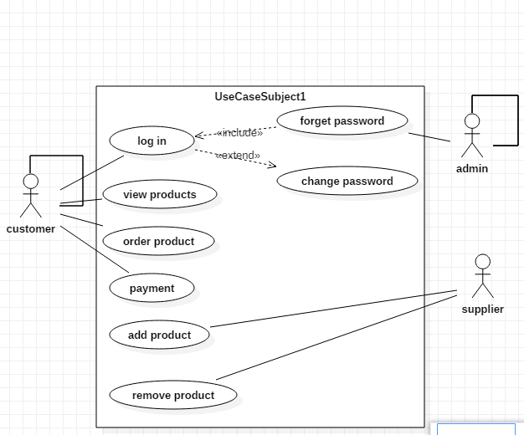

* 1. **ERD:**
* **ENTITES:**

1. Product
2. Customer
3. Supplier
4. Stock
5. Order

* **ATTRIBUTES:**

Products (**id**, name, description, price)

Customer (**id**, name, phone_no, email, address)

Supplier (name**, id**, email, contact number)

Stock (product_name, product_id(**Fk**), quantity)

Order (customer_id(**fk**), product id, quantity, calculate bill)

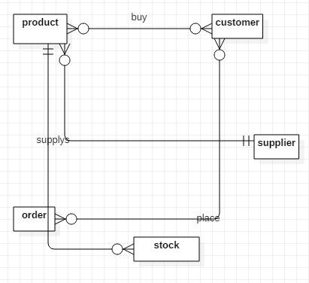

* 1. **DFD:**

DED of wholesale management system is:

Customers do the following task:

* Enter its data
* Place order

Admin do the following task:

* Maintain and enter product record.
* Maintain and enter stock records.
* Maintain and enter supplier record

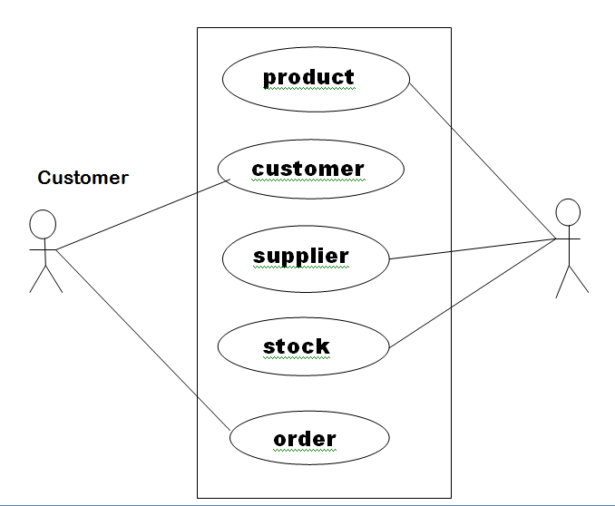

* 1. **Interface:**

**2.4.1 Admin page:**

First page is admin page:

1. Enter User name.
2. Enter password.
3. Click login

After login following option is show on screen:

1. Product
2. Customer
3. Stock
4. Supplier
5. Order

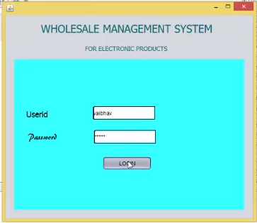

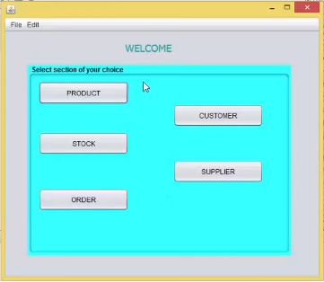

**2.4.2 product page:**

In product section there are following options:

* Add new product
* Delete product
* Update product record
* Search product

In add product user can enter.

* Name
* Id
* Price
* Description
* Quantity

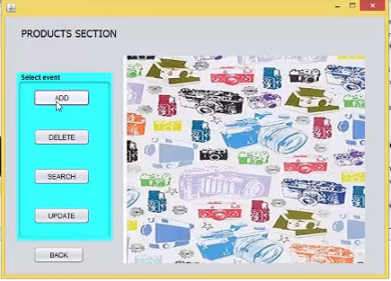

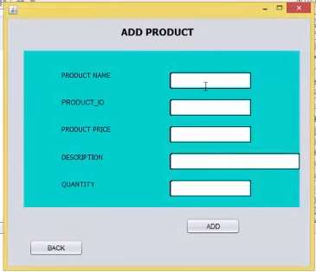

**2.4.3 Customer page:**

In customer section there are following options:

* Add new customer
* Delete customer
* Update customer record
* Search customer

In add customer, customer enter name phone number, email, and address and then click on add. After entering data customer will assign a unique id.

